Case Study 6: ATM Transaction Simulation

1. Problem Statement
Simulate a bank account with deposit and withdrawal transactions.

2. Objectives
- Add deposits to the balance.
- Allow withdrawals only when the balance is sufficient.

3. Assumptions
- The opening balance and transaction amounts are non-negative.
- D means deposit and W means withdrawal.

4. Algorithm
1. Read opening balance.
2. Read transaction type and amount.
3. Add a deposit or subtract a valid withdrawal.
4. Reject invalid transactions.
5. Display final balance.

5. Flowchart
START → Input balance → Input transaction → Deposit or withdrawal? → Update or reject → Display balance → STOP
For a drawn flowchart, use: oval for START/STOP, parallelogram for input/output, rectangle for calculations, and diamond for decisions.

6. Pseudocode
READ balance, type, amount
IF amount <= 0: reject
ELSE IF type == D: balance = balance + amount
ELSE IF type == W AND amount <= balance: balance = balance - amount
ELSE: reject
DISPLAY balance

7. Python Source Code
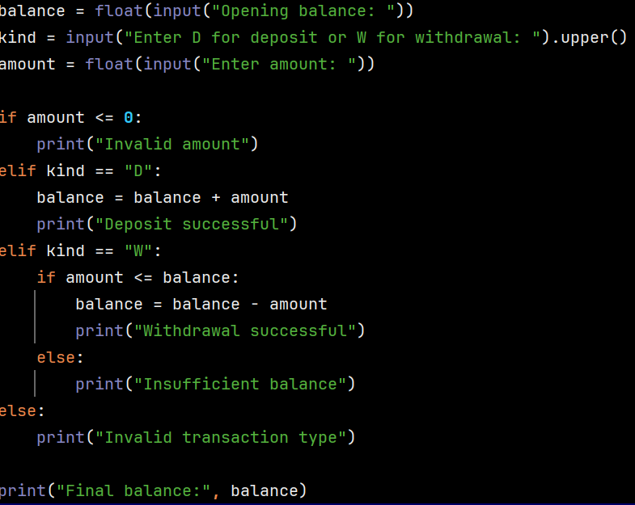

8. Test Cases
Test 1: balance 1000, deposit 500 → 1500. Test 2: balance 100, withdrawal 200 → insufficient balance and balance remains 100.

Sample Output
Input: opening balance ₹1000, type W, amount ₹200
Output: Withdrawal successful
Final balance: 800.0

9. Conclusion
The program demonstrates if-else conditions and updates a balance based on transactions.

v

